**Life Cycle of a Butterfly Learning Guide**

**Written by Annika Srivastava and Susan Karbowski**

**Edited by Caroline Karbowski and Kimmy J**e**on**

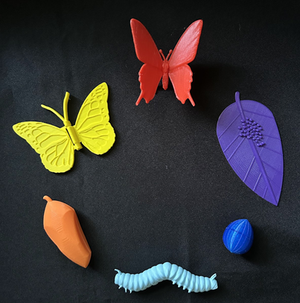



See3D.org



CHOKING HAZARD - This product contains small parts and should be kept out of the reach of children under age 3. Not a toy.

# Table of Contents**:**

Table of Contents: 2

**Butterfly Egg 4**

Credit: 5

Overview: 5

Orienting the Model: 5

Walkthrough: 6

Citations: 6

**Butterfly Eggs on a Leaf 7**

Credit: 8

Overview: 8

Orienting the Model: 8

Walkthrough: 9

Citations: 11

**Caterpillar 12**

Credit: 13

Overview: 13

Orienting the Model: 14

Walkthrough: 14

Citations: 16

**Chrysalis 17**

Credit: 18

Overview: 18

Orienting the Model and Walkthrough: 19

Citations: 20

**Butterfly & Hinged Butterfly 21**

Credit: 22

Overview: 22

Orienting the Realistic Butterfly Model: 23

Orienting the Hinged Butterfly Model: 25

Key Terms: 26

Citations: 29

# Butterfly Egg

**Written by Annika Srivastava and Susan Karbowski**

**Edited by Caroline Karbowski and Kimmy Jeon**

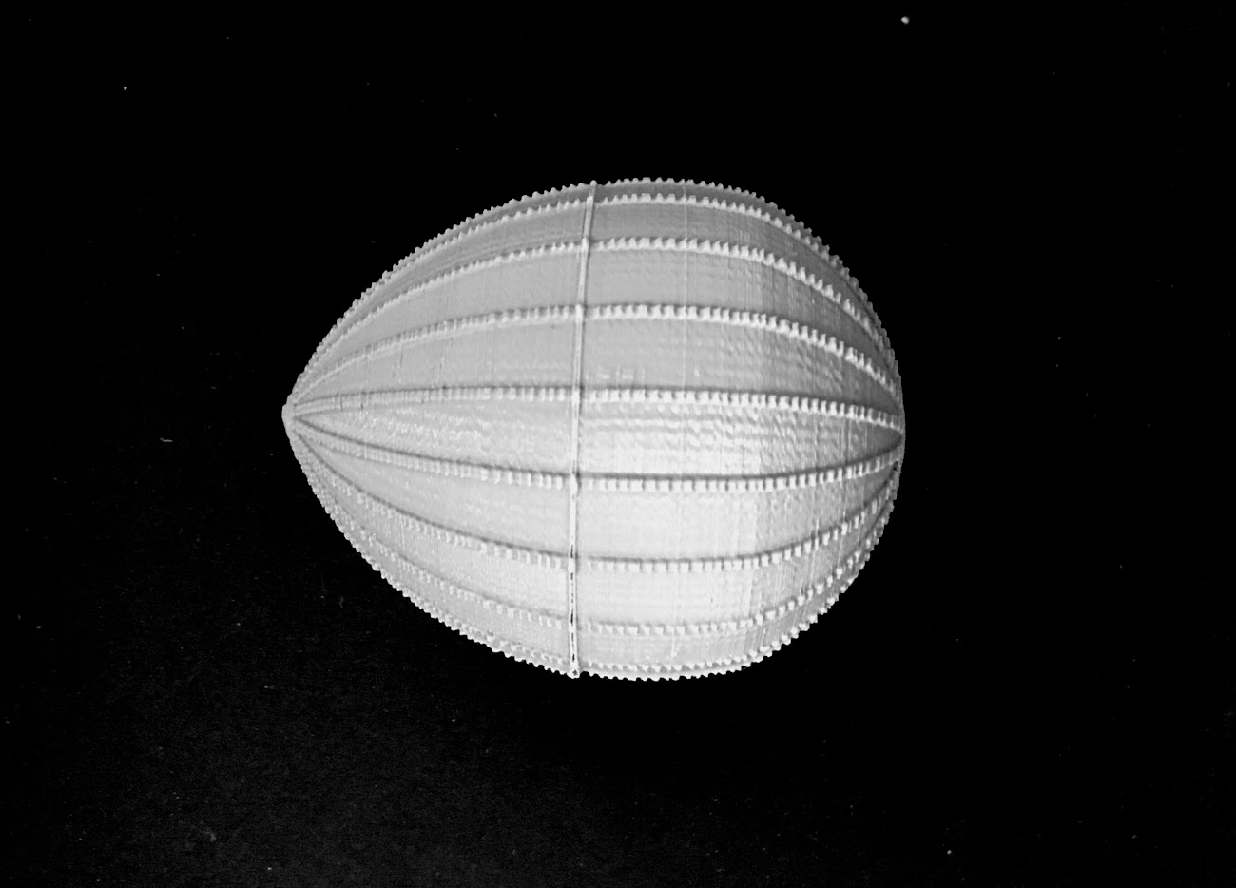



See3D.org

## Credit:

This model was designed by Varneyjlv for See3D, Inc. [*https://www.thingiverse.com/thing:4197984*](https://www.thingiverse.com/thing:4197984)

## Overview:

This model depicts the structure and shape of a monarch butterfly egg. When a butterfly lays an egg, it also releases glue to ensure that the egg sticks to the leaf.

## Orienting the Model:

Hold the egg so that the pointed tip of the model is facing the sky and the rounded side of the model touches your palm.

## 

## Walkthrough:

Notice the model’s shape is a sphere with a pointed end. The model has a hard texture, similar to a real butterfly egg that has a hard shell **chorion** on the outside to protect the inside contents. The rising vertical lines on the egg are **ridges**. A real monarch butterfly egg is 1.2 mm (0.047 in) tall and 0.9 mm (0.034 in) wide, which is about the size of a pinhead. This 3D model is roughly 30 times larger than a real butterfly egg.

## Citations:

Monarch Joint Venture. (2022). (publication). [*2022 Monarch Research Review*](https://mjv.nyc3.cdn.digitaloceanspaces.com/documents/2022-Monarch-Research-Review.pdf). https://mjv.nyc3.cdn.digitaloceanspaces.com/documents/2022-Monarch-Research-Review.pdf

Monarch Joint Venture. (2025). [*Life cycle*](https://monarchjointventure.org/monarch-biology/life-cycle/egg). https://monarchjointventure.org/monarch-biology/life-cycle/egg

# Butterfly Eggs on a Leaf

**Written by Annika Srivastava and Susan Karbowski**

**Edited by Caroline Karbowski and Kimmy Jeon**

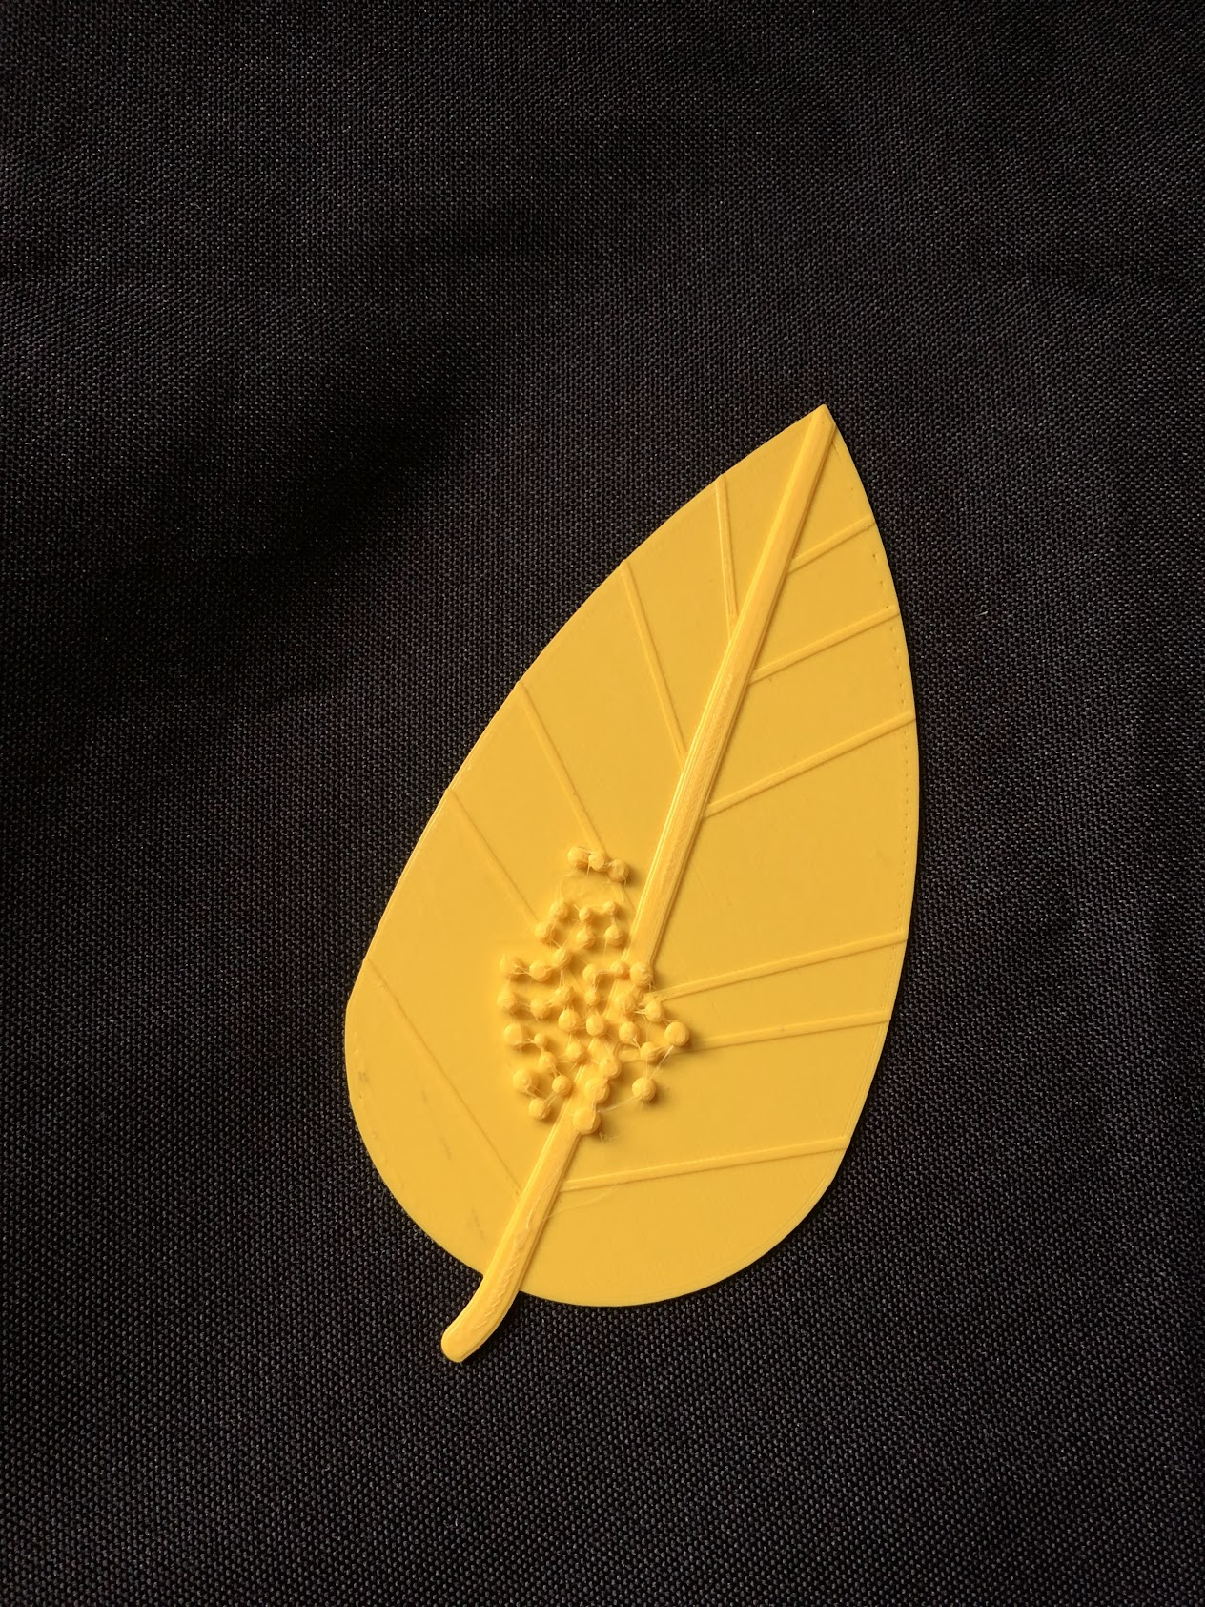



See3D.org

## Credit:

Model designed by Varneyjlv for See3D, Inc. [*https://www.thingiverse.com/thing:4197984*](https://www.thingiverse.com/thing:4197984)

## Overview:

This model depicts multiple butterfly eggs on a leaf. In the life cycle of a butterfly, the eggs are the first stage.

## Orienting the Model:

There are two sides of the model: a smooth side, and a bumpy side. Place the smooth side on a flat surface.

## Walkthrough:

The model consists of a **leaf**, which has a spade shape, where it is rounded near the stem and pointy at the other end. On the bumpy side of the model, there are raised lines which are the leaf’s veins.

Find the raised circular bumps on the leaf. These are the **butterfly eggs**, which are shaped like small spheres or balls.

1. **Butterfly eggs:** An adult, female butterfly lays her eggs on a leaf, usually on the underside. Some butterflies lay multiple eggs, because the majority of them do not survive. Other butterflies, like monarchs, will lay just one egg at a time. Each egg is 1.5mm, approximately the size of a pinhead. Depending on the butterfly species, they will lay their eggs in the spring, summer or fall. After about four days the eggs will hatch into caterpillars.
2. **Leaf:** Once the butterfly hatches, the hatched caterpillar eats the leaf for food. Most often, the leaf is from a milkweed plant.

# 

## Citations:

The Academy of Natural Sciences of Drexel University. (2018). [*Butterfly life cycle*](https://ansp.org/exhibits/online-exhibits/butterflies/lifecycle/). https://ansp.org/exhibits/online-exhibits/butterflies/lifecycle/

American Museum of Natural History. (2017, April 3). [*The life cycle of a butterfly*](https://www.amnh.org/explore/news-blogs/on-exhibit-posts/butterfly-life-cycle). https://www.amnh.org/explore/news-blogs/on-exhibit-posts/butterfly-life-cycle

Monarch Joint Venture. (2025). [*Life cycle*](https://monarchjointventure.org/monarch-biology/life-cycle/egg). https://monarchjointventure.org/monarch-biology/life-cycle/egg

# 

# Caterpillar

**Written by Annika Srivastava and Susan Karbowski**

**Edited by Caroline Karbowski, Kimmy Jeon**

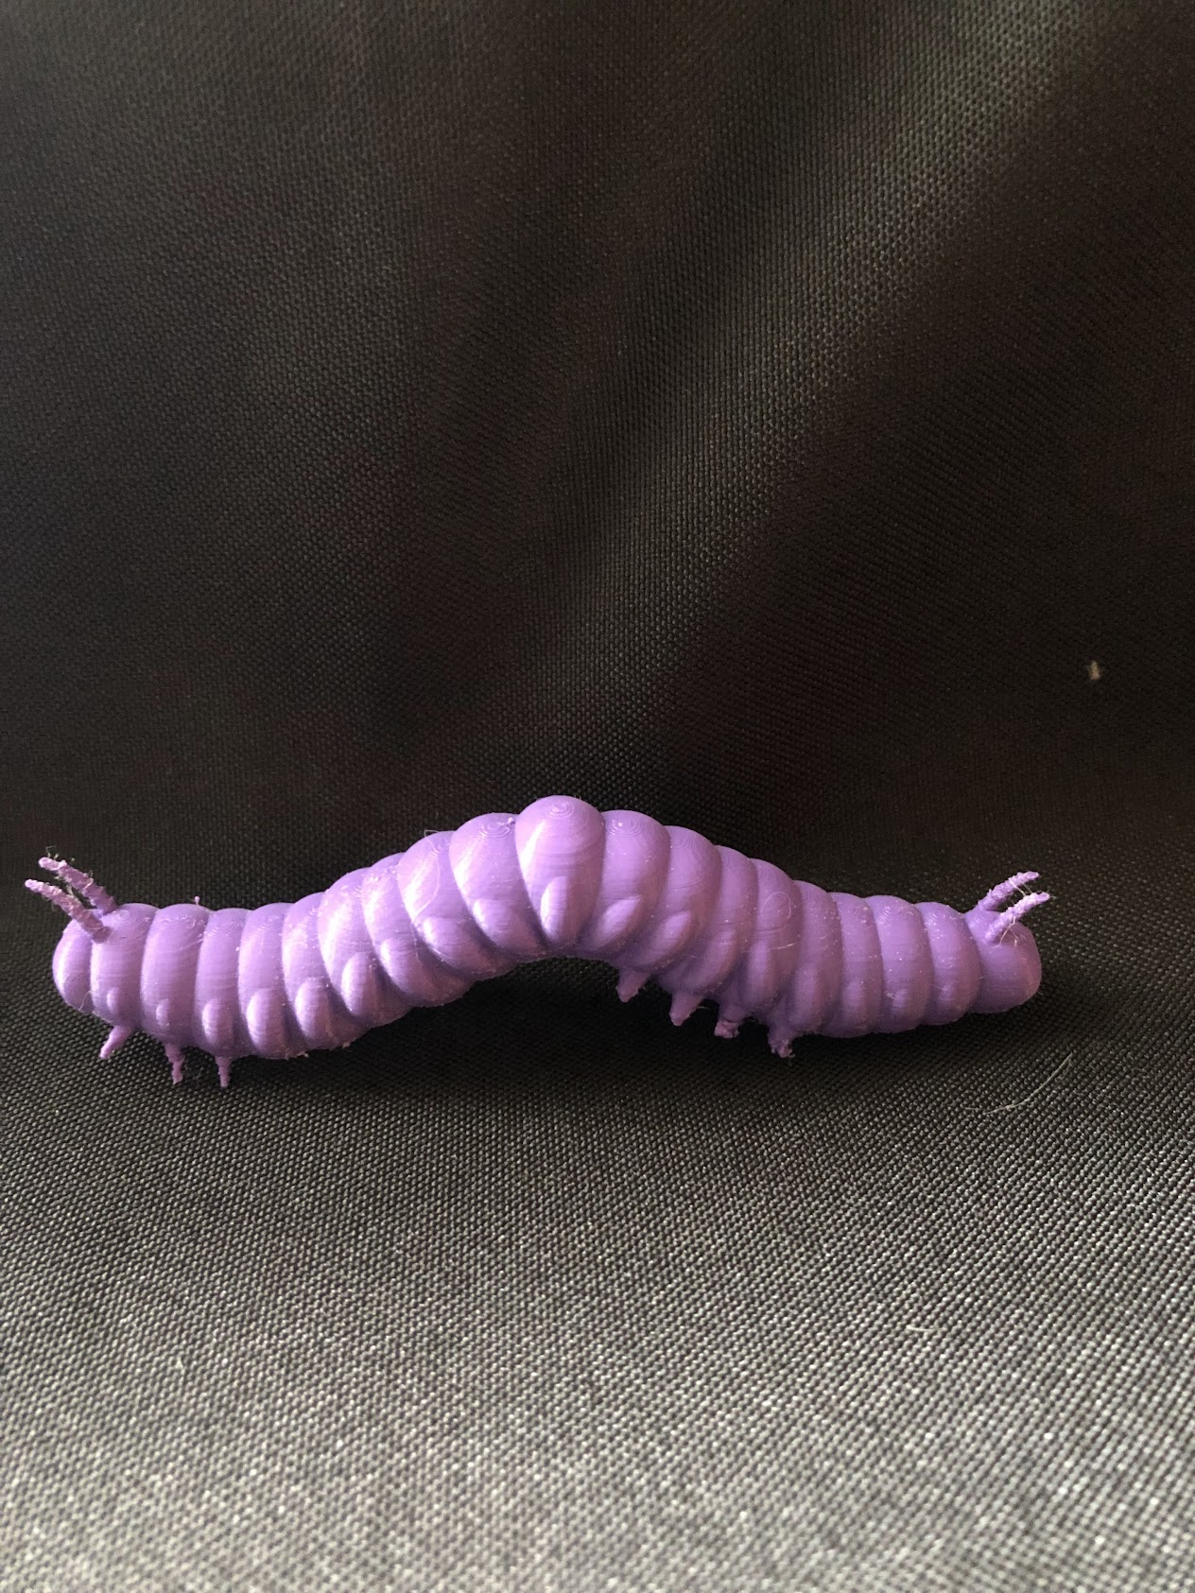



See3D.org

## Credit:

This model was designed by mdherren on Thingiverse. <https://www.thingiverse.com/thing:4824071>

## Overview:

When a butterfly egg hatches, a larva emerges from the shell. Butterfly larvae are commonly known as caterpillars, and this is the third stage of metamorphosis. During the larva stage, the caterpillar must consume as much protein as possible. When they mature into adult butterflies, the protein will help them produce eggs. Caterpillars are cylindrically shaped with multiple segments, allowing for flexibility in movement. They molt or shed their skin five times while they grow. Each molt is called an instar. This model exhibits the form and motion of a caterpillar at the fifth instar. Caterpillars, upon hatching, can be as small as 2 mm, the size of a grain of rice and grow to 45 mm right before the final stage of metamorphosis which would be the size of a AAA battery. Caterpillars can take 7-17 days to grow.

## Orienting the Model:

Feel for the side of the model that has several sets of little stubs or points sticking out all across the cylinder. One end has three sets of stubs grouped together. This is the front of the model. The head is at this tip. Place the model on a surface with the stubbed side facing down noticing which end is the head.

## Walkthrough:

1. Feel for two tiny rods on each end of the model. These are the two sets of tentacles. Even though caterpillars have 12 tiny eyes (not on this model) they have weak eyesight. These tentacles are their essential tools for navigation. Tentacles also aid the sense of smell to find food. Caterpillars have strong jaws that help them chew leaves quickly. Their mouth leads to a long intestine. Unfortunately, they can only digest ¼ of their food.
2. Move your hand along the model. You will feel several sections or segments that in real life can move independently. The three sections closest to the head of the caterpillar serve as the thorax. The thorax stores the intestines and the silk gland.
3. Next, feel the remaining sections under the thorax. These serve as the abdomen of the caterpillar. The abdomen stores the nervous system, final intestines, and anus.
4. On the undersides of both the thorax and abdomen, you will find several stubs. These are the legs of the caterpillar. The six legs near the head in the thorax section are the thoracic legs, which are true legs that hold pieces of plants when eating. The legs in the abdomen section are prolegs, which are fake legs. The prolegs have small hooks that allow the caterpillar to cling to plants while moving.

## Citations:

Encyclopædia Britannica (Ed.). (2025, February 7). [*Caterpillar*](https://www.britannica.com/science/caterpillar). https://www.britannica.com/science/caterpillar

Monarch Watch. (n.d.). [*Monarch anatomy*](https://www.monarchwatch.org/biology/). Monarch Watch: Monarch Biology. https://www.monarchwatch.org/biology/

Oberhauser, K., & Kuda, K. (1997). [Appendix B: A Field Guide to Monarch Caterpillars (Danaus plexippus)](https://ecos.fws.gov/ServCat/DownloadFile/150661.). In *Monarch Monitoring Protocol* (pp. 1–14). essay, (Department of Ecology, Evolution and Behavior; University of Minnesota. https://ecos.fws.gov/ServCat/DownloadFile/150661.

# 

# Chrysalis

Written by Annika Srivastava and Susa**n Karbowski**

**Edited by Caroline Karbowski and Kimmy Jeon**

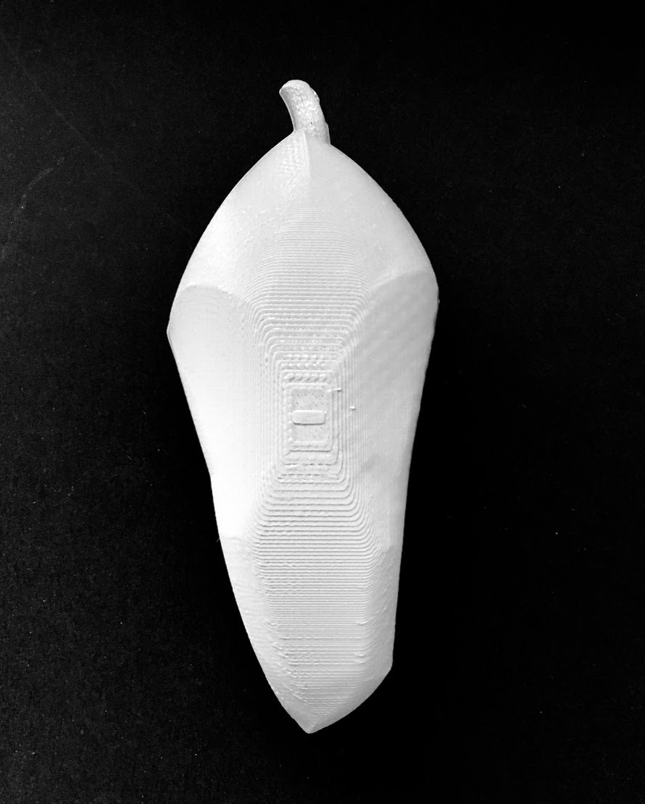





See3D.org

## Credit:

This 3D model was designed by Varneyjlv for See3D. [*https://www.thingiverse.com/thing:4197984*](https://www.thingiverse.com/thing:4197984)

## Overview:

When a caterpillar is fully grown, it becomes a pupa, commonly referred to as a chrysalis. The caterpillar completes its transition to a butterfly by breaking down and recycling its own cells while inside the chrysalis. This is the third stage of metamorphosis. The pupa stage of a monarch lasts eight to fifteen days under normal conditions. Once it is fully transformed, a butterfly will emerge from the shell. In nature a chrysalis is approximately 3 cm long or about the size of a banana slice or standard LEGO® brick. This 3D model is about 2.33 times larger than a real chrysalis.

## Orienting the Model and Walkthrough:

1. Feel for a short stub and point it upward. This is a **cremaster** that the caterpillar uses to hang from leaves, branches, or rocks.
2. The thicker, cylindrical part of the model is the **chrysalis**. It is a protective shell that provides shelter and camouflage to the transforming caterpillar. It starts out as a silk encasing and then hardens. Inside the chrysalis, the caterpillar’s digestive fluids break itself down from the inside out. Its old cells are broken down into imaginal cells, which can become any type of cell. These imaginal cells are used to create the new body of the butterfly. The chrysalis will change colors and then once the butterfly is fully developed, it will either crack its chrysalis open or it will release fluids to soften the shell.

## 

## Citations:

The Academy of Natural Sciences of Drexel University. (2018). [*Butterfly life cycle*](https://ansp.org/exhibits/online-exhibits/butterflies/lifecycle/). https://ansp.org/exhibits/online-exhibits/butterflies/lifecycle/

Espace Pour la vie Montreal. (n.d.). [*From egg to butterfly: Monarch chrysalis (or pupa)*](https://espacepourlavie.ca/en/chrysalis-or-pupa). Insects and other arthropods. https://espacepourlavie.ca/en/chrysalis-or-pupa

Macpherson, F. (2021, February 2). [Fantastic facts about butterflies: Everything you need to know, according to science](https://www.sciencefocus.com/nature/fantastic-facts-about-butterflies-everything-you-need-to-know-according-to-science). *BBC Science Focus*. https://www.sciencefocus.com/nature/fantastic-facts-about-butterflies-everything-you-need-to-know-according-to-science.

Monarch Joint Venture. (2025). [*Life cycle*](https://monarchjointventure.org/monarch-biology/life-cycle#:~:text=Monarchs%2C%20like%20other%20butterflies%20and,a%20variety%20of%20flowering%20plants.). https://monarchjointventure.org/monarch-biology/life-cycle#:~:text=Monarchs%2C%20like%20other%20butterflies%20and,a%20variety%20of%20flowering%20plants.

# Butterfly & Hinged Butterfly

Written by Annika Srivastava

Edited by Caroline Karbowski, Kimmy Jeon, and Emril Bennett

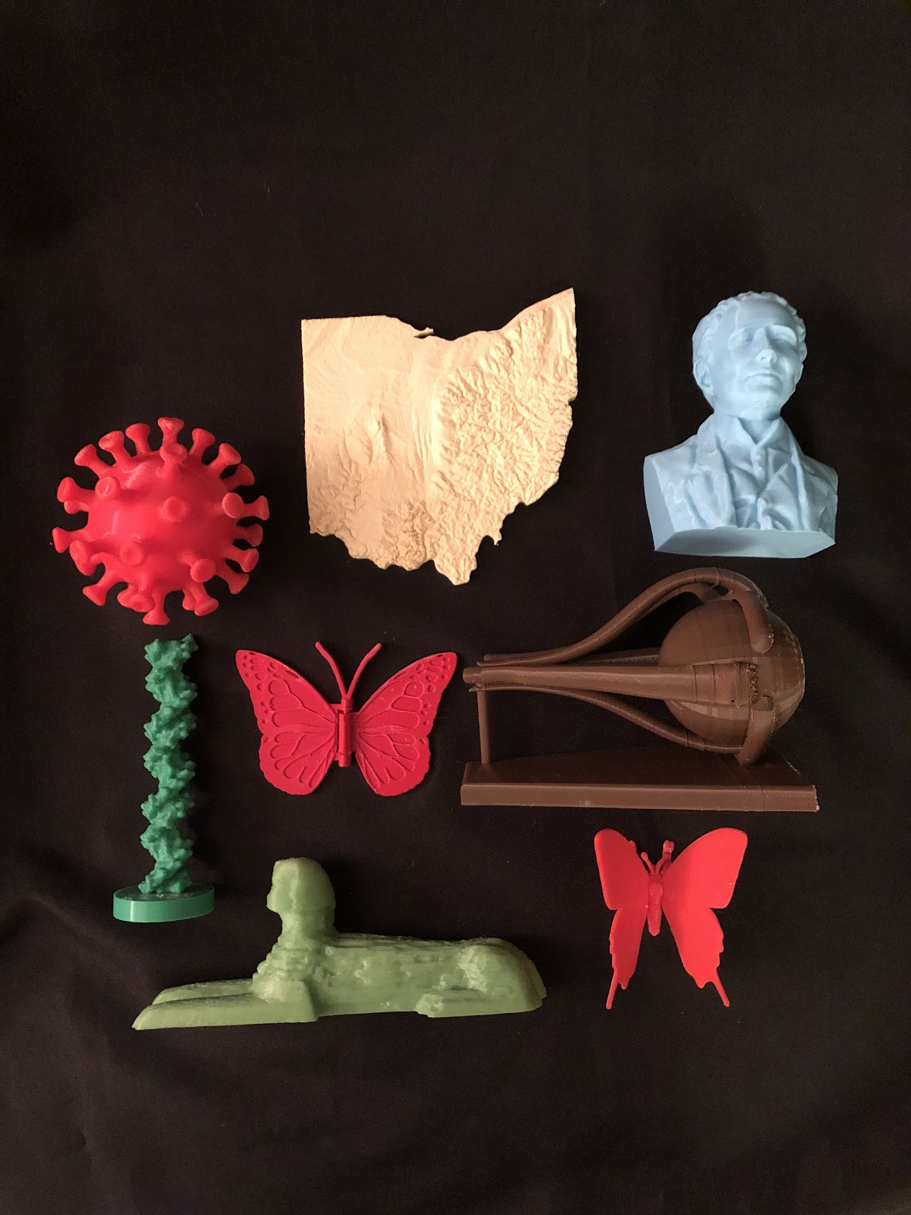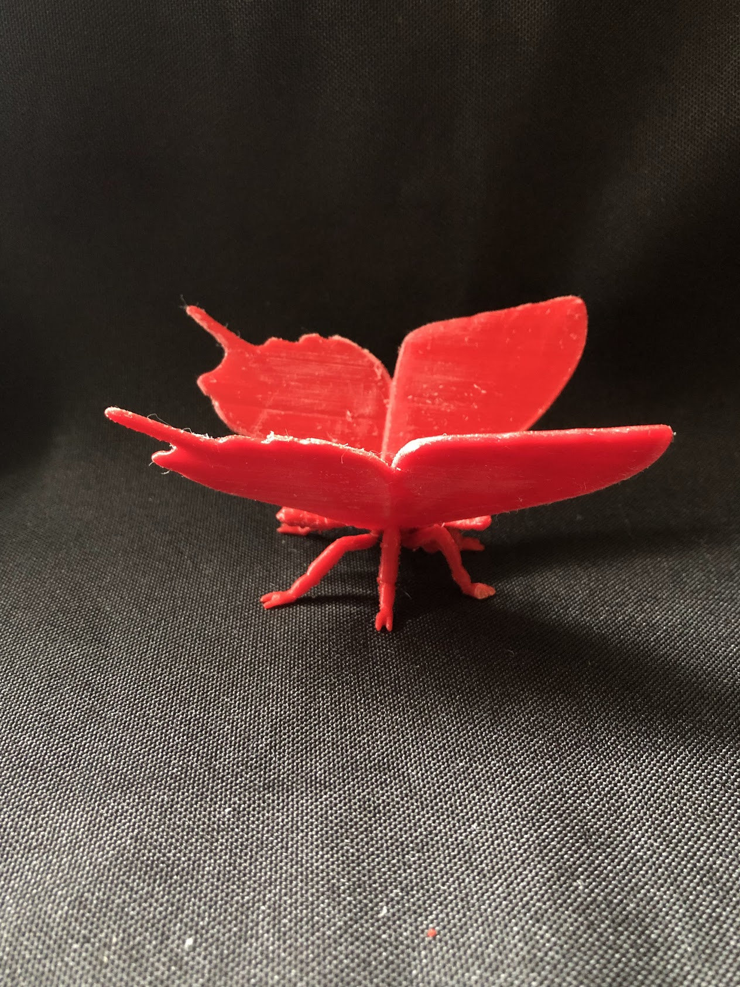



See3D.org

## Credit:

The remixed realistic butterfly was designed for See3D, Inc. on Thingiverse. <https://www.thingiverse.com/thing:6915536>

The remixed hinged butterfly was designed for See3D, Inc. on Thingiverse. <https://www.thingiverse.com/thing:6915512>

## Overview:

The butterfly models depict the anatomy of a butterfly including the following parts: antenna, compound eye, proboscis, head, thorax, legs, abdomen, hindwing, and forewing. While a butterfly undergoes a metamorphosis of egg-larva-pupa-adult, these models are the final stage of the life cycle of a butterfly, the adult stage. Its wings are expanded as it crawls out of the chrysalis, and the butterfly is ready to feed, find a mate, and begin the cycle again.

## Orienting the Realistic Butterfly Model:

The realistic butterfly is a 3D representation of a butterfly with no moving parts. Locate a long cylinder hanging on the center of the model which serves as the butterfly’s body. Above the body are two attached sets of flat triangles, each set depicting a butterfly wing. At a front view, there are **antennae**, which are two small tubes with spheres on each end. Orient the model so these two tubes are facing towards you. Beneath the middle of the body there are six bent **legs**, each with three joints. The third joint, furthest away from the butterfly’s body, contains two toes (a sharp cut that leaves the end of the legs at a V-shape) to provide stability. Place the legs on a flat surface.

Directly beneath the antennae, there is a small circular spiral with a point, which is the **proboscis** (hard to feel). The **head** is the top face of the main cylinder, behind and attached to the antenna. On the head’s small sphere shape, are the **compound eyes** but you cannot feel or see these on the model. Directly behind the head, find a longer cylinder shape that feels smooth. This is the **thorax**. Behind the thorax, there is another cylinder shape that is about twice the size of the thorax. This cylinder has small ridges, and represents the **abdomen**.

To the left and right of the thorax, there are two smooth and rounded triangle shapes, which are the butterfly’s **forewings**. The forewings are located on the front half of the model. Behind the forewings, there are two more wings, located on the back half of the model. These are the **hindwings**, which have a wavy border with a point on each end.

# 

## Orienting the Hinged Butterfly Model:

The hinged butterfly is a 2D representation with flapping wings. In the center, feel for two curved tubes that form a print Y shape. These are the **antennae**. Orient the model so the antennae are at the top. Attached to the antennae is a small cylinder, which is the **head**. Underneath the head, there are two cylinders: one long and one small. These two cylinders together represent the **thorax** and **abdomen**. They are more functional parts to help the model’s wings flap, rather than a realistic depiction.

The butterfly **wing’s** tactile oval and circle shapes represent the pattern on the butterfly that can be seen from the front and the back of the butterfly.

Note that the wings can be lifted up and down. This represents how a butterfly flies: both wings move up and then both wings move down.

## Key Terms:

1. **Antennae:** The antennae’s primary function is to smell, which allows the butterfly to avoid toxic plants and find flowers with nectar. Their sense of smell is also beneficial for mating to detect pheromones of a mate. In addition to the sense of smell, antennae can sense the wind direction, sound, balance, and location, which are especially useful during migration.
2. **Proboscis:** The model depicts the proboscis curled up, but the proboscis can unravel to look like a string coming out of the butterfly’s head. This part can be considered the butterfly’s mouth, which sucks up nectar, juice, and water. Since a butterfly cannot chew, the proboscis is necessary to ingest liquids from flowers and fruits.
3. **Head:** The head houses various organs to eat and sense its surroundings. The antennae, proboscis, and compound eye are all located on the head.
4. **Compound Eye:** A butterfly has two compound eyes, which allow the butterfly to see its surroundings. Rather than having one lens like humans, butterflies have almost 17,000 lenses, which can be considered mini eyes. With its compound eyes, the butterfly can see up, down, behind, and forward. Unlike humans, butterflies can also see ultraviolet light in order to easily detect pollen in a flower.
5. **Thorax:** The thorax houses the butterfly’s four wings and six legs, allowing the butterfly to move. Muscles within the thorax power butterfly wings and legs.
6. **Abdomen:** The abdomen contains the digestive tract, spiracles, and reproductive organs. The digestive tract allows the butterfly to digest food and process waste. For the butterfly to breathe, there are small holes called spiracles located on the abdomen for air to enter. Female butterflies develop and keep their eggs in the abdomen.
7. **Forewings and hindwings:** The forewings and hindwings allow the butterfly to fly. Their patterns also protect the butterfly from predators through camouflage and attract other butterflies. Poisonous butterflies store toxins in their wings as well.
8. **Legs:** In addition to allowing the butterfly to walk, the legs have taste sensors to find plants for food or lay eggs. Each leg has a foreleg, midleg, and hindleg to allow for movement.

## Citations:

Cambridge Butterfly Conservatory. (2025, January 24). [*All about butterflies*](https://www.cambridgebutterfly.com/all-about-butterflies/#:~:text=Antennae%20are%20sensory%20organs%20used,butterfly%27s%20version%20of%20a%20nose). https://www.cambridgebutterfly.com/all-about-butterflies/#:~:text=Antennae%20are%20sensory%20organs%20used,butterfly%27s%20version%20of%20a%20nose

Davidson, M. W. (2015, November 13). [*Butterfly proboscis*](https://micro.magnet.fsu.edu/optics/olympusmicd/galleries/darkfield/butterflyproboscis.html#:~:text=A%20tubular%20sucking%20organ%2C%20the,the%20shape%20of%20the%20blossom). Molecular Expressions. https://micro.magnet.fsu.edu/optics/olympusmicd/galleries/darkfield/butterflyproboscis.html#:~:text=A%20tubular%20sucking%20organ%2C%20the,the%20shape%20of%20the%20blossom

Encyclopædia Britannica, Inc. (2025). [*Parts of the butterfly and moth*](https://kids.britannica.com/students/assembly/view/53025). https://kids.britannica.com/students/assembly/view/53025

Florida Museum. (n.d.). [*Butterfly Life Cycle*](https://www.floridamuseum.ufl.edu/educators/resource/butterfly-life-cycle/). For Educators. https://www.floridamuseum.ufl.edu/educators/resource/butterfly-life-cycle/

Macpherson, F. (2021, February 2). [*Fantastic facts about butterflies: Everything you need to know, according to science*](https://www.sciencefocus.com/nature/fantastic-facts-about-butterflies-everything-you-need-to-know-according-to-science). BBC Science Focus Magazine. https://www.sciencefocus.com/nature/fantastic-facts-about-butterflies-everything-you-need-to-know-according-to-science